
Solution Architecture

Date | 02 JULY 2026
Team ID | SWTID-2026-1374
Project Name | RISING WATERS
Maximum Marks | 5 Marks

Solution Architecture Diagram:
Provide a high-level visual representation of your solution's architecture. Use the structural layout below as a template to map out your Presentation Layer, Application Layer, and Data Layer. Fill in the specific technologies and components for your project directly into the boxes to create your architectural diagram.
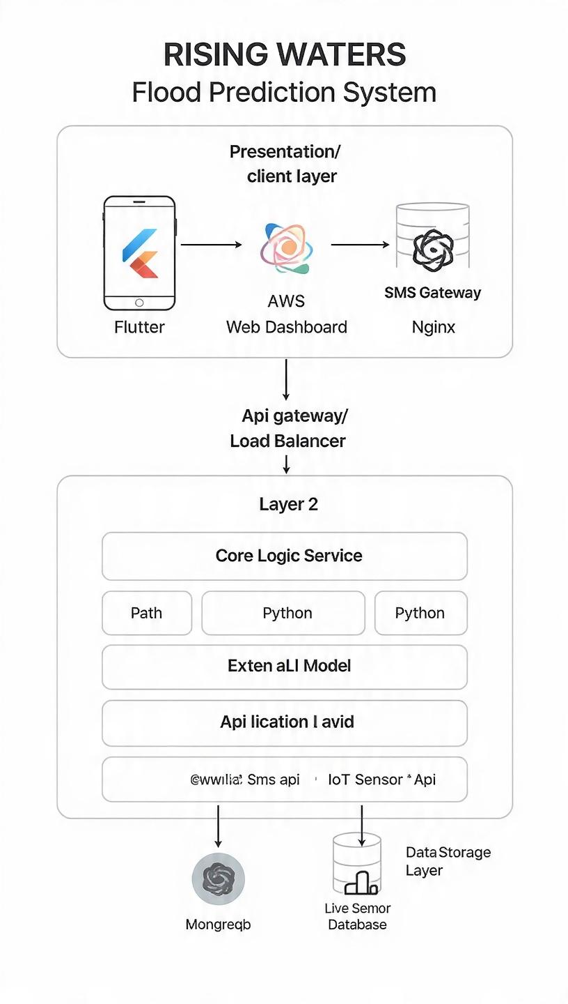


Component Description Table

Component Name | Description / Role in Architecture | Technologies Used
PRESENTATION LAYER | User-facing interface where residents receive alerts and officials view the dashboard | Mobile app flutter,web dashboard react
API GATEWAY | Manage all the incoming requests ,routes them to services | AWS API gateway,Nignx
MICROSERVICES | Core backend logic.Handles authentication ,ML-based flood prediction, and external API integrations | Auth service:firebase auth/JWT
DATABASE | Stores historical flood data,real time sensor data,and user details for alerts | PostgoreSQL,MongoDB,AWS S3

